A000-AM,C-Mayan Classic Period Terracotta Globular Bowl with Two Registers

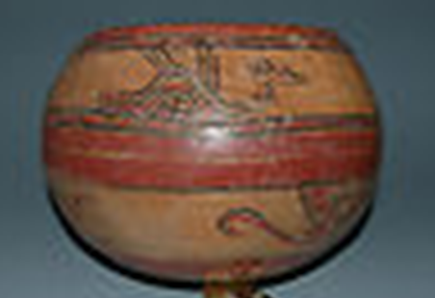

Fig. 1. Mayan Classic Period Terracotta Globular Bowl with Two Registers

**Case no.: 10**

**Accession Number: A….**

**Formal Label:** Mayan Classic Period Terracotta Globular Bowl with Two Registers

**Display Description:**

Two rows of ancient glyphs on this finely modeled vessel painted in red and black on an orange background provides a cryptic dedicatory inscription to the deceased with whom it was placed as the mark of eminence. Fierce and imperious yet strangely beautiful, there is little doubt that this masterful globular vessel, rare among the Maya, served an important ceremonial function for its esteemed bearer. While the vessel’s historical function is lost to the ages, posterity has granted it a renewed purpose as an enduring memory of the Maya’s arcane civilization.

**LC Classification:**

**Date or Time Horizon:** 800-1250 CE

**Geographical Area:** **Map, GPS coordinates:**

**Cultural Affiliation:** Mayan

**Medium:** Modeled reddish-orange clay with white slip and pigments (black, brown, and red).

**Dimensions:**

**Weight:**

Condition: A beautiful and well-modeled example, the vessel has strong ancient patina, only lightly cleaned, with surface encrustation, only minor surface pitting, a light stress line to each side, one ancient chip at the inside of rim, otherwise intact.

**Provenance:**

**Discussion:**

This Late Classic Period, 900-1100 CE, globular vessel is a testament to a civilization just past its peak, yet still crafted with a sense of tradition and artistry as the Mayan abyssal plunge into extinction was underway. The Classic Maya period (250-900 A.) had been an age of profound intellectual and artistic achievements, with monumental pyramids and magnificent urban centers in homage to their gods. At a time when the Western world languished after the fall of the Roman Empire, the New World experienced an age of imperial grandeur, when great city-states like Tikal and Copán proclaimed Mayan hegemony over the emerald forests of Mexico and Guatemala. Theirs was a sophisticated but startlingly brutal civilization—wars were waged not for land or prestige, but for blood, for slaves sacrificed atop the great pyramids to appease the god’s insatiable lust for human flesh.

The Mayan world was an arcane realm where Earth connected through godly intermediaries and their own rulers with both the Upperworld and the Underworld. This was a society infused with spirituality, a society that reflected both the majesty and savagery of the rain forests. Like the ancient societies of the Mediterranean, ceramic forms were vital to the Mayan economy and traded alongside coveted resources such as Jade, obsidian, flint, and shells. This globular vessel was one of these connecting points with both the Upperworld and the Underworld and it spoke to the people in these two registers as the end was nearing

**References:**

**AP:** 6